Behaviour Genetics

Group 3

Marie-Therese Bleicher, Xavier Fernández Sala, Nora Kopsch, Marta Simón

**Estimating heritability of human seeking behaviour in laboratory dogs**

**Results**

Firstly, we started with a prior that contained no fixed effects and that corresponded to an inverse-gamma prior. We set “animal” as a random effect in order to estimate the additive genetic values (VA) based on the population’s pedigree. Overall, the posterior distribution showed a practically constant mean value as well as a homogeneous variation around the respective mean value.The values for the additive genetic effects fluctuated in an irregular manner. The variance component “density of animal” did not show a normal distribution and the values demonstrated a tendency towards zero. The trace of units showed a more constant pattern around the mean value, but it was not as consistent as in the combined model. Since no trend was seen in the values of the combined model, it allowed us to continue working with this model.

For the next step, we tried to improve the first model by setting a longer burnin as well as a higher number of iterations. Additionally, we increased the thin from 10 to 50. The results neither showed an improvement nor obvious differences. The “animal” and “unit” models behaved similarly to the previous run. Subsequently, we tested the model for autocorrelation. As seen below, all values for the component “animal” as well as for the component “unit” differed from zero. That indicated a high autocorrelation between the values. However, autocorrelation decreased with the number of iterations. We expected this trend, since the distance between the values drawn by the model increased. Therefore, we were able to continue working with this respective model.

Table 1: Autocorrelation values for model 1 between “animal” and “units”

|  |  |  |
| --- | --- | --- |
| **Animal** | | |
|  | **Animal** | **Units** |
| Lag 0 | 1.00000000 | -0.54844869 |
| Lag 50 | 0.76015434 | -0.45604875 |
| Lag 250 | 0.44834328 | -0.28713682 |
| Lag 500 | 0.28790592 | -0.19350074 |
| Lag 2500 | -0.07503562 | 0.03338796 |
| **Units** | | |
|  | **Animal** | **Units** |
| Lag 0 | -0.54844869 | 1.000000e+00 |
| Lag 50 | -0.45999276 | 2.738785e-01 |
| Lag 250 | -0.26451222 | 1.930178e-01 |
| Lag 500 | -0.17910895 | 1.133337e-01 |
| Lag 2500 | 0.06409463 | -1.528434e-05 |

To estimate the most accurate value for heritability (h2 = VA / (VA + VE + VAE + 2COVAE), we applied the respective formula on our models. The R commands for it can be found in the R-Script. As the first model did not contain any fixed effects and only counted “animal” as a random effect, the next step was to add different effects to the model.

For the second model, we added “sex” as a fixed effect in order to estimate if the sex would have an influence on the heritability. The interval of the posterior distribution overlapped zero, which indicated that “sex” did not have any effects on the heritability.

In order to add random effects into the model, we created a new prior which we applied on the third model. The random effects were subdivided into the factors “animal” and “age”. An overview of all heritability estimates and the HPD-intervals can be found in table 2.

Table 2: Summary of the estimated heritabilities and Highest Posterior Distributions for all three models

|  |  |  |  |
| --- | --- | --- | --- |
|  | **Model 1** | **Model 2** | **Model 3** |
| Heritability (h2) | 0.002263119 | 0.006301459 | 0.002577556 |
| HPD interval (lower - upper) | 0.0002832174 - 0.198509 | 0.0006998308 - 0.1877136 | 0.0003735091 - 0.1818067 |

Finally, we compared all three models in order to be able to select the most suitable one. To do so, we compared the deviance information criteria (DIC) of each model. As shown in table 3, the third model, which included “animal” and “age” as random factors and “sex” as fixed factor, attained the lowest DIC value. Based on that, the third model would be rated as the most suitable one, however, the DIC values did not differ remarkably.

Table 3: Deviance information criteria (DIC) for each established model

|  |  |  |
| --- | --- | --- |
| **DIC model 1** | **DIC model 2** | **DIC model 3** |
| 1238.561 | 1239.079 | 1237.914 |

Figure 1 presented the posterior distribution of fixed effects in the third model. We were not able to detect any noteworthy differences when comparing the third model with the first one that did not include any fixed effects. The mean of the iterations increased slightly from 0.06336 to 0.07956. The pattern of the mean of the iterations did not show any irregular trend and the density of intercept showed a normal distribution. The effective sample sizes for this model were 68.9 (animal), 581.9 (age), and 290 (units).

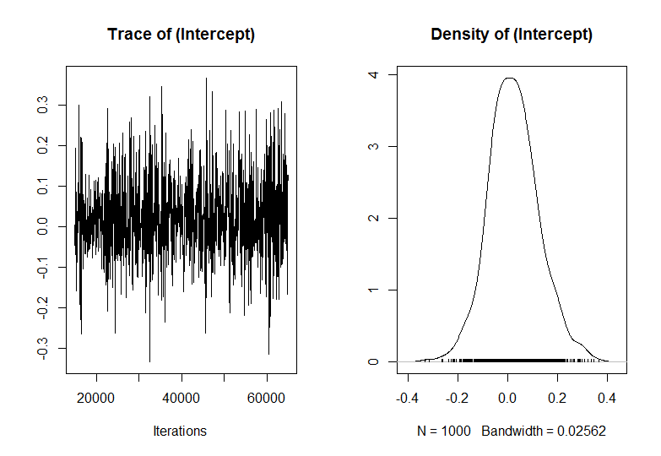

Figure 1: Posterior distribution of model 3 with “sex” as fixed effect and “animal” and “age” set as random effects

After we unravelled the different determined random effects (animal, age) and separated them from the units, the trace of animal (Figure 2, A1) had an irregular pattern with a high fluctuating frequency of the mean values. The trace of age (Figure 2, B1) showed a mean around zero, with some outliers that demonstrated a high variance. Moreover, plots for density of animal (Figure 2, A2) and density of age (Figure 2, B2) did not show a normal distribution and values were assembled closed to zero, similarly as the first model without fixed effects. Contrary, the mean values for the units (Figure 2, C1) behaved mainly consistent and did not show an irregular trend and the density of units (Figure 2, C2) seemed to be normally distributed.

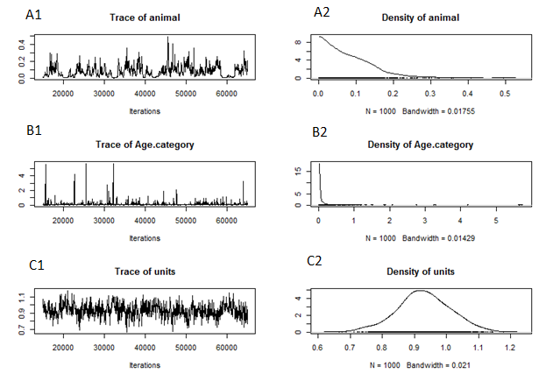

Figure 2: Posterior distributions of the variance components of model 3, based on analysis with nitt = 65000; burnin = 15000; and thin = 50 in MCMCglmm

**Discussion**

Domestic animals have been artificially selected for many years. This selection focused on certain traits that were favourable for the people that kept them. Throughout the selection process the proportion of the selected traits increased in the population, whereas the genetic variation decreased. After selecting for a trait for many generations, it was very likely to get genetically fixed in the population, meaning that all individuals had the same genotype. In the case of companion animals, such as dogs, the human seeking behaviour was a desirable trait and therefore expected to get genetically fixed after several generations due to the selection process. Consequently, the variability of the trait should have been reduced.

Our set of data came from a population of laboratory beagle dogs, for which the pedigree was completely known and which were raised under the same conditions. This fact excluded the possibility of different environmental factors influencing the “human seeking behaviour” and therefore, the observed differences in the dogs’ behaviour could not be explained by them. Simultaneously, as all the dogs were related up to some degree, we expected the genes that determine the phenotype for this behaviour to be similar in this population.

As said before, fixation of the trait reduced the genetic variability. Consequently, we expected low heritability, as it is defined as the proportion of variance that can be explained by genetics. Furthermore, the heritability, was neither influenced by the sex nor the age of the animals.

In conclusion, the heritability for the trait “human seeking behaviour” was almost zero (h2 = 0.002577556) in this laboratory population of beagles. Probably it was due to the fact that all the individuals shared the same genes linked to this behaviour. Hence, the variability in this behaviour could only be explained by other processes such as personality, cognitive and learning abilities, for instance.